**Software Requirement Specification**

**For**

**E-Commerce website**

**Prepared by:**

**Mohammed Anas-721220104025**

**Neethi Kumar -721220104027**

**Ramana -721220104037**

**Sakthi Kumar -721220104040**

**Suriya Prakash -721220104053**

**Academic Year 2023-2024**

**1)Introduction**

Our e-commerce website is dedicated to creating an unparalleled online shopping destination, providing users with a seamless, secure, and enjoyable experience. We offer a vast selection of products, support various vendors, and prioritize user data security. Personalization, comprehensive order management, and responsive customer support are at the heart of our platform. With a focus on mobile shopping, we aim to be accessible on the go. We also encourage a sense of community through product reviews and user interactions. Our purpose is not only to provide technical excellence but to be a trusted partner in the digital marketplace, meeting and exceeding the expectations of our stakeholders.

**1.2 Document Conventions**

Entire document should be justified.

* Convention for Main title

**Font face:** Times New Roman Font style: Bold

**Font Size:** 18

* Convention for Sub title

**Font face:** Times New Roman Font style: Bold

**Font Size:** 18

* Convention for body

**Font face:** Times New Roman

**Font Size:** 14

**1.3 Scope of the project devolepment**

The scope of our e-commerce website is to establish a dynamic and user-centric online marketplace, effectively replacing traditional brick-and-mortar shopping with a comprehensive internet-based application. This platform is designed to serve both vendors and consumers, enabling vendors to showcase and manage their products while empowering consumers to browse, select, and purchase items with ease.

Our e-commerce website offers a broad array of features and functionalities, including product listings, secure payment processing, order tracking, personalized recommendations, and community engagement. It caters to diverse user needs and preferences, making it an ideal choice for various businesses and consumers seeking to conduct online transactions conveniently.

Adaptable and scalable, this platform can be seamlessly integrated into various contexts, from small businesses to large enterprises. The modular design allows for easy customization and expansion to meet specific requirements and accommodate evolving needs.

The development of this e-commerce platform leverages modern web technologies and robust back-end infrastructure to ensure performance, security, and cross-platform compatibility. This project aims to provide a cost-effective solution for online commerce while enhancing the user experience and promoting digital engagement in the retail industry.

**1.4 Technologies**

Front End – HTML,CSS,JAVASCRIPT

Back End – SpringBoot

DataBase – MySQL

**2.Overall Description**

**2.1 Product Discriptive**

Use Case Diagram for E-Commerce Website

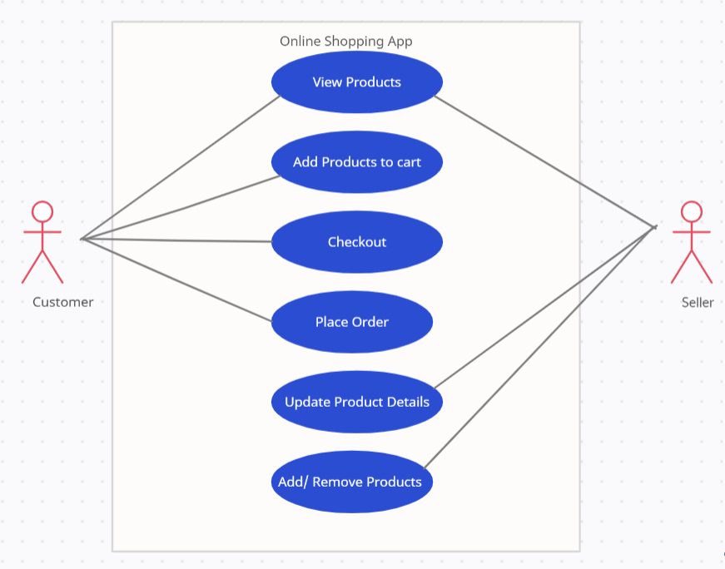

In this Customer can visit the webpage and view the products and can buy the products which is in the catelogue. The Order item details and the delivery details should be shown to the customer. The seller can view the products and maintain the products. Only the seller can add and remove the products from the list

**2.2 Product Function**

Entity relationship Diagram

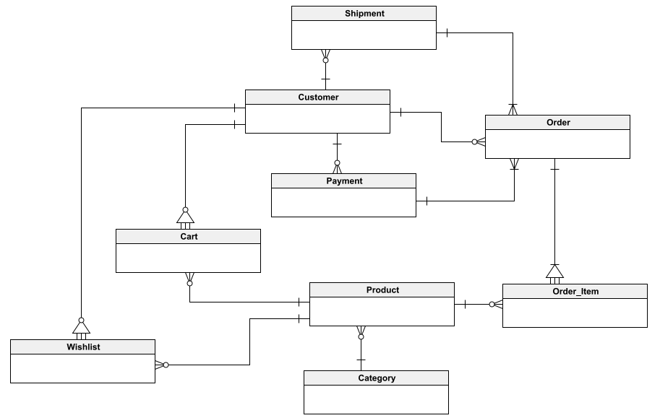

The entity-relationship diagram captures the core components and their relationships. At its center is the "Customer" entity, linked to "Order" to represent the purchasing process. Vendors are another vital entity, connected to "Product" to illustrate the listings. The "Payment" entity links with "Order" to signify transaction details. "Category" and "Cart" entities enable user to view and save products list. Overall, the ERD showcases a structured framework for the e-commerce ecosystem, defining how customers, vendors, products, orders, payments, and user-generated content interact within the system.

**2.3 Class Diagram**

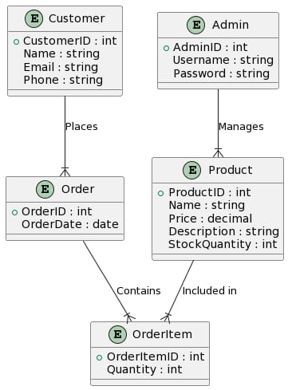

Users can have multiple Carts and place multiple Orders.Orders are associated with one User and contain multiple Products.Products are categorized under Categories.Users can write Reviews for Products.Administrators manage Products, Categories, and generate Reports.Payment is linked to an Order for processing.User Management handles the addition, removal, and updates of User accounts.

**2.4 Operating Environment**

Our e-commerce website will operate within a versatile Windows-based environment, ensuring compatibility with various editions. It will be accessible through popular web browsers, such as Microsoft Internet Explorer, Google Chrome, Mozilla Firefox, and others, providing users with flexible choices.

To access this online product, users will only require a stable internet connection. The hardware configuration for seamless performance includes a 40 GB hard disk, a 15" color monitor, and a standard 122-key keyboard. Basic input devices such as a keyboard and mouse, as well as output device like a monitor is supported, ensuring a user-friendly and accessible experience for all potential users.

**2.5 Assumptions and dependencies**

* **User-Friendly Interface:** The system is designed to be user-friendly, prioritizing ease of use for all users.
* **Database for User Information:** User, product, and transaction information will be stored in a database accessible via the website.
* **Search Functionality:** Users will have access to a robust search feature, enabling efficient product discovery.
* **24/7 Availability:** The e-commerce website will operate 24 hours a day to accommodate users across various time zones.
* **Access from Any Device:** Users can access the website from any device with internet browsing capabilities and an internet connection.
* **Secure User Authentication:** Users must provide correct usernames and passwords to access their online accounts and perform actions securely.
* **Specific Hardware and Software:** The product's operation is dependent on the hardware and software configurations chosen for hosting.
* **Project Development:** The project development and execution will rely on defined requirements and specifications.
* **Database for User Information:** The accessibility of user information in the database is crucial for account management.

**2.6 requirements**

Software Configuration:-

This software package is developed using java as front end which is supported by sun micro system. Microsoft SQL Server as the back end to store the database.

**Operating System:** Windows NT, windows 98, Windows XP Language: Java Runtime Environment, Net beans 7.0.1 (front end)

**Database:** My SQL Server (back end)

**Hardware Configuration:**- Processor: Pentium(R)Dual-core CPU Hard Disk: 40GB

**RAM:** 256 MB or more

**2.7 Data Requirements**

Data requirements for our e-commerce platform encompass a fundamental interaction between inputs and outputs. Users initiate this process by entering queries, which can range from account creation requests to product selections and cart management. The system then responds by communicating with the database, retrieving and modifying data as needed. The most crucial output is the delivery of detailed account information to users, including order history, personal details, and transaction records. This output also involves timely responses to queries, such as order confirmations and shipping status updates, ensuring an informed and satisfactions. Timestamps user for order tracking and maintaining account history. Moreover, users have the ability to access and view the current contents of their shopping carts, making well-informed decisions during the purchasing process.

**3.External Interface Requirement**

**3.1 GUI**

The graphical user interface (GUI) of our e-commerce platform offers an intuitive and versatile environment for users to seamlessly navigate a wide array of products. Whether you're a customer exploring diverse offerings or an administrator managing the platform, the GUI ensures an efficient and user-friendly experience.

**Key features of the GUI include:**

1. Product Discovery: Users can easily browse and search for products across various categories, making it simple to find what they're looking for.

2. Quick Reports: Access to essential reports such as order history, shipment status, and purchase summaries for customers, as well as inventory management and sales reports for administrators.

3. Customization: Administrators can tailor the user interface to meet specific business requirements, including the addition, editing, or removal of product categories.

4. Consistency: A uniform template is maintained throughout the interface, offering a standard look and feel to ensure a cohesive user experience.

**Login Interface:**

For new users, a straightforward registration process allows them to create an account. Once registered, users can log in by entering their username and password. Any input errors prompt an error message for immediate correction.

**Administrator's Control Panel:**

Administrators benefit from a dedicated control panel that allows them to manage users, add, edit, or remove products, and oversee various aspects of the e-commerce platform, including sales and inventory management. The control panel streamlines administrative tasks and ensures effective platform management.

**4.System features**

The users of the system should be provided the surety that their account is secure. This is possible by providing:-

* User authentication and validation of members using their unique member ID
* Proper monitoring by the administrator which includes updating account status, showing a popup if the member attempts to issue number of books that exceed the limit provided by the library policy, assigning fine to members who skip the date of return
* Proper accountability which includes not allowing a member to see other member’s account. Only administrator will see and manage all member accounts

**5.Non Functional Requirements**

**5.1 Performance Requirements**

The proposed system that we are going to develop will be used as the Chief performance system within the different campuses of the university which interacts with all users. Therefore, it is expected that the database would perform functionally.

* The performance of the system should be fast and accurate
* It should handle expected and non-expected errors in ways that prevent loss in information and long downtime period. Thus it should have inbuilt error testing to identify invalid username/password
* The system should be able to handle large amount of data. Thus it should accommodate high number of products and users without any fault

**5.2 Safety Requirement**

The database may get crashed at any certain time due to virus or operating system failure. Therefore, it is required to take the database backup so that the database is not lost. Proper UPS/inverter facility should be there in case of power supply failure.

**5.3 Security requirements**

* + System will use secured database
  + Normal users can just read information but they cannot edit or modify anything except their personal and some other information.
  + System will have different types of users and every user has access constraints
  + Proper user authentication should be provided
  + No one should be able to hack users’ password
  + There should be separate accounts for admin and members such that no member can access the database and only admin has the rights to update the database

**5.4 requirement attributes**

* + There may be multiple admins creating the project, all of them will have the right to create changes to the system. But the members or other users cannot do changes
  + The project should be open source
  + The Quality of the database is maintained in such a way so that it can be very user friendly to all the users of the database

**5.5 Bussiness Requirements**

A business rule is anything that captures and implements business policies and practices. A rule can enforce business policy, make a decision, or infer new data from existing data.This includes the rules and regulations that the System users should abide by. This includes the cost of the project and the discount offers provided. The users should avoid illegal rules and protocols. Neither admin nor member should cross the rules and regulations.

**5.6 User Requirements**

The users of the system are assumed to have basic knowledge of the computers and internet browsing. The administrators of the system should have more knowledge of the internals of the system and is able to rectify the small problems that may arise due to disk crashes, power failures and other catastrophes to maintain the system. The proper user interface, user manual, online help and the guide to install and maintain the system must be sufficient to educate the users on how to use the system without any problems.

The admin provides certain facilities to the users in the form of:-

* + Backup and Recovery
  + Forgot Password
  + Data migration i.e. whenever user registers for the first time then the data is stored in the server
  + Data replication i.e. if the data is lost in one branch, it is still stored with the server
  + Auto Recovery i.e. frequently auto saving the information
  + Maintaining files i.e. File Organization
  + The server must be maintained regularly and it has to be updated from time to time